**Name:- Rana Vraj PRN:- 2017033800104962**

Practical 5

1. Write a program to unpack a 16-bit BCD number

.model small

.data

a dw 1234h

b db ?

c db ?

d db ?

e db ?

.code

main proc near

mov ax,@data

mov ds,ax

mov ax,a

AND ax,000fh

mov b,al

mov ax,00f0h

AND ax,a

ROR ax,4

mov c,al

mov ax,0f00h

AND ax,a

ROR ax,8

mov d,al

mov ax,0f000h

AND ax,a

ROR ax,12

mov e,al

mov ax,04ch

int 21h

endp

end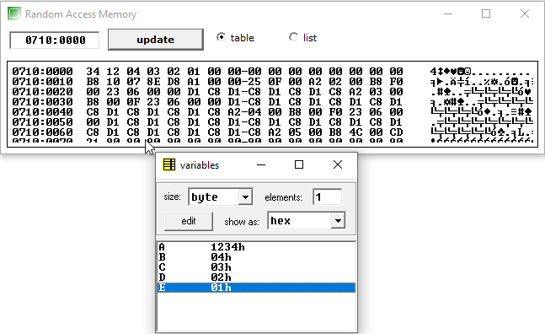

1. Write a program to pack 32-bit number into a BCD number

.model small

.data

a dd 01020304h

r dw ?

.code

main proc near

mov ax,@data

mov ds,ax

mov ax,a+2

and ax,000fh

ror ax,8

mov bx,ax

mov ax,a+2

and ax,0f00h

ror ax,12

add ax,bx

mov dx,ax

mov ax,a

and ax,000fh

mov bx,0000h

mov bl,al

mov ax,a

and ax,0f00h

ror ax,4

add ax,bx

add ax,dx

mov r,ax

mov ax,04ch

int 21h

endp

end

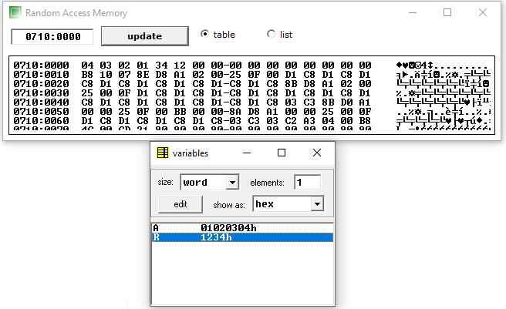

1. Write a program to pack an n-byte array of 4 elements into a BCD number of 16 bits.

.model small

.data

a db 01h,02h,03h,04h

len db $-a

r dw ?

.code

main proc near

mov ax,@data

mov ds,ax

mov ax,0000h

mov cx,0000h

mov cl,04

lea si,a

loop1:

mov al,[si]

ror ax,cl

add ax,bx

mov bx,ax

inc si

mov ax,0000h

inc cl

inc cl

inc cl

inc cl

cmp len,dl

je loop2

dec len

jmp loop1

loop2:mov r,bx

mov ax,04ch

int 21h

endp

end

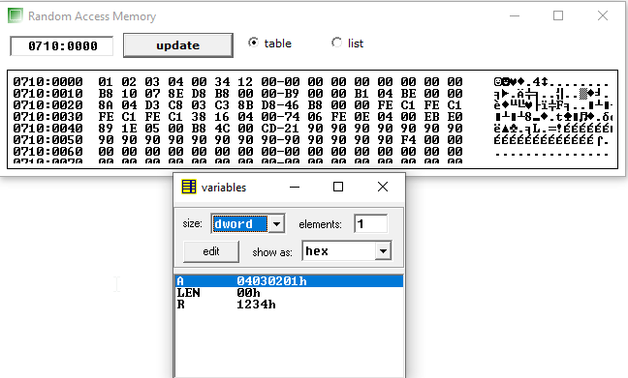

1. Write a program to convert 8-bit number from BCD to binary number

.model small

.data

a db 25h

b db ?

r db 07 dup (?)

r1 db 02 dup(?)

.code

main proc near

mov ax,@data

mov ds,ax

lea si,r

mov cl,00h

mov ax,0000h

mov al,a

mov bx,0002h

loop1:

div bl

mov b,al

mov [si],ah

cmp al,cl

je loop2

inc si

mov ax,0000h

mov bx,0002h

mov al,b

jmp loop1

loop2:

lea si, r

lea di,r1

mov cx,0003h

LoopM:

mov ax,0000h

mov ax,[si]

cmp ax,0000h

je next1

cmp ax,0001h

je next2

cmp ax,0100h

je next3

cmp ax,0101h

je next4

next1:

mov [di],al

jmp next

next2:

mov [di],al

jmp next

next3:

mov al,10h

mov [di],al

jmp next

next4:

mov al,11h

mov [di],al

jmp next

next:

inc si

inc si

inc di

dec cx

cmp cx,0000h

je over

jmp LoopM

over:

mov ax,04ch

int 21h

endp

end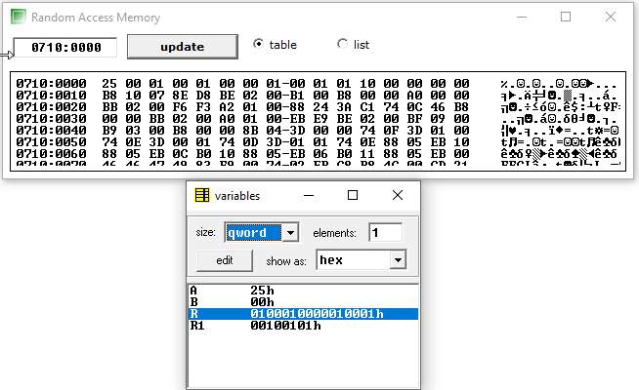

1. Write a program to convert 16-bit number from BCD to binary number

.model small

.data

a dw 2631h

b dw ?

c dw ?

d dw ?

e dw ?

f dw ?

g dw ?

h dw ?

i dw ?

.code

main proc near

mov ax,@data

mov ds,ax

mov ax,a

AND ax,000fh

mov b,ax

mov ax,00f0h

AND ax,a

ROR ax,4

mov c,ax

mov ax,0f00h

AND ax,a

ROR ax,8

mov d,ax

mov ax,0f000h

AND ax,a

ROR ax,12

mov e,ax

mov bx,03E8h

mul bx

mov f,ax

mov ax,d

mov bx,64h

mul bx

mov g,ax

mov ax,c

mov bx,0ah

mul bx

mov h,ax

mov ax,f

add ax,g

adc ax,h

adc ax,b

mov i,ax

mov ax,04ch

int 21h

endp

end

